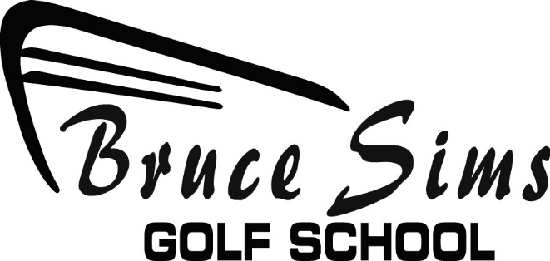
JUNIOR ACADEMY ENROLLMENT APPLICATION
Student Name_________________________________ DOB_____________
Address____________________________________City___________Zip_______
Phone________________________Email_______________________________
Credit Card Number___________________________Exp.__________
One time Administration Fee $100.00/non refundable
ACADEMY POLICIES & PROGRAM RULES
1, Parents or student are responsible for scheduling all private lessons, if desired which will come with an additional charge, by contacting
Bruce Sims/214-475-5168 Jeff Kennedy/214-354-0698
2. Payment must be paid in full each month and will be on a recurring schedule,
3. All (4) sessions must be completed in the same month. No refunds or credit will be granted to the next month for make-up for missed sessions.
4. Sessions will begin promptly at start time. Students arriving late will not be granted make-up for missed time.
5. All students will BEGIN IN LEVEL ONE.
6. Progression through the levels are based on proficiency and knowledge of the skills for the current level. The instructors will determine when the student will move to the next level based upon the skills assessment for that level.
7. Developmental Level is by invitation only class. Students must pass assessment challenge in order to be considered for promotion and invitation.
8. STUDENT MUST DRESS APPROPRIATELY FOR GOLF.
9. The Academy is a year round program (12 months)
10. If the student is going to be away from the Academy for more than 60 days a new application must be submitted and current fees will apply.
11, ALL CANCELATIONS OF ACADEMY MUST BE IN A WRITTEN FORM OR EMAIL AND SUBMITTED (30) DAYS IN ADVANCE.
Does Student have clubs? YES/NO
Students borrowing clubs form the Academy are required to return clubs at the end of the session
Allergies: YES/NO if yes please specify_______________________
Parent or Guardian Signature_______________________________________Date__________

